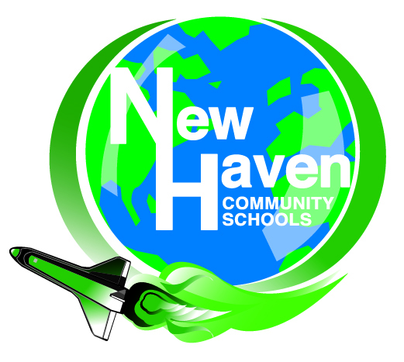
New Haven Community Schools
Non-Homestead Millage Renewal
March 8, 2016

Frequently Asked Questions

What will the millage renewal cost homeowners?
Nothing. The 18 mills Non-Homestead Millage Renewal only applies to local business, industrial and commercial property or property that is not the owner’s primary residence (the home in which you live). There is NO IMPACT on homeowners.

Will this increase taxes on Non-Homestead properties?
No. This is a renewal, not an increase, so businesses will keep paying the same millage rate they are currently paying.

What does “Non-Homestead” mean?
Non-Homestead properties represent business, industrial, commercial, and some agricultural property and “second homes.” It does not include a family’s primary residence.

How important is this election?
Extremely. The Non-Homestead Millage comprises almost $2.8 million, or 21 percent, of New Haven Community Schools’ operating revenues. The State of Michigan assumes school districts levy and collect the full 18 mills, and subtracts this amount from each district’s per pupil allowance. For New Haven Community Schools this is equal to more than $1,500 per pupil. These are the funds used to pay for staffing, purchase textbooks and classroom supplies, and operate the district’s school buildings. These local funds are deducted from the per pupil money the school district receives from the state. If the millage renewal is not approved, the state will not make up the difference, and New Haven Community Schools will lose $2.8 million in revenue each year.

How are Michigan school districts funded?
Public schools in Michigan receive most of their funding on a per pupil basis from the state. The amount a school district receives per pupil is called the Foundation Allowance. The per pupil foundation allowance for New Haven Community Schools is currently $7,391. This represents the major portion of New Haven Community School’s revenues and is funded from two sources: (1) local revenue — 18 mills collected on Non-Homestead property in the district, and (2) state revenue.

Why do we need a millage election?
The Non-Homestead Millage is required by Proposal A (the state’s school funding structure), in order for New Haven Community Schools to receive it’s full per pupil foundation allowance from the state. The law requires that the 18 mills on Non-Homestead property cannot be levied unless it comes before voters in an election. New Haven Community School’s residents last approved the operating millage in 2007, and a 10-year renewal period is requested in the March 8, 2016 election.

What is the Headlee Rollback?

New Haven’s Non-Homestead Millage has been permanently reduced or rolled back periodically since 2000. The rollback is called a Headlee Rollback. A Headlee Rollback occurs when local units of government (including school districts) are required by law to reduce, or “rollback,” the millage rate when the growth on existing property is greater than the rate of inflation. As a result of a Headlee Rollback, school districts collect less revenue than is allowable under Proposal A.

Why are voters being asked to renew 21 mills, when the maximum Non-Homestead levy by law is 18 mills?
Beginning in 2003, the school district’s operating millage rate has been reduced below 18 mills through a Headlee Rollback. To restore the full operational dollars authorized by the state under Proposal A, voters approved additional mills in 2007 to ensure full funding from the state. It is predicted that additional Headlee Rollbacks will occur over the next 10 years and the district needs to ensure that our funding is protected.

Although the district is seeking renewal of 21 mills (18mills + 3mills) the district will only levy the maximum allowable 18 mills that is legally authorized to be levied in any given year. The balance of 3mills would be approved and available in the event of future Headlee Rollbacks.

I thought schools no longer received funding through property taxes, so why is the school district asking for a millage renewal?
Funding for school districts changed significantly in 1993-94 when Michigan voters passed Proposal A. Under Proposal A, the state provides the majority of the funding to public schools, but to receive full funding, schools must levy and collect locally 18 mills on Non-Homestead property in their district.

Is this a new tax?

No. This is a renewal of a millage approved by the voters in 2007 for 10 years and it has been levied every year since then. The district has voter approval to levy 18 mills on Non- Homestead property in 2017, but it expires after that levy.

What if the millage is not approved?

The revenue generated from the 18 Non-Homestead mills equals almost $2.8million or 21 percent of the district’s operating budget. If this millage does not pass, the state will not replace the funding and New Haven Community Schools will be forced to substantially reduce or eliminate programs and services to offset the funding loss.

Can the district use bond money to cover the loss in revenue if the millage is not approved?

No. These funds are restricted by law to building and site projects and cannot be used for general fund expenditures such as staffing, textbook and classroom supplies, or to operate our school buildings.

Further Questions can be directed to the Superintendent of Schools
Mr. Todd R. Robinson
Email: trobinson@newhaven.misd.net
Phone: 586 749-5123

